OJT Back-Up

1) PMS Login →Organization Tree → HR → HR → HR

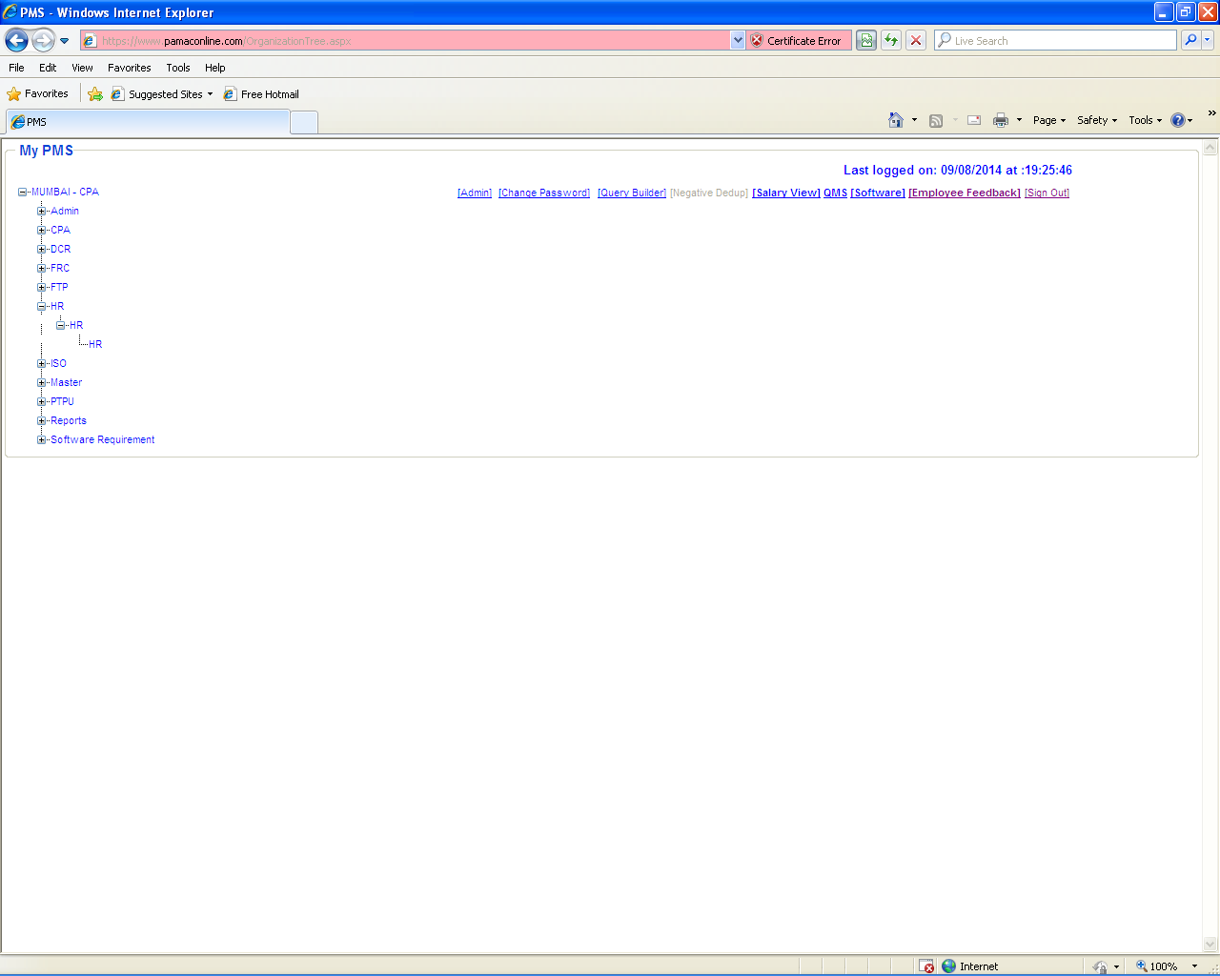
2) HR → Productivity.

Select “Productivity” option to “Add/Update BackUp Name” against Particular UPDATING AUTHORITY in OJT.

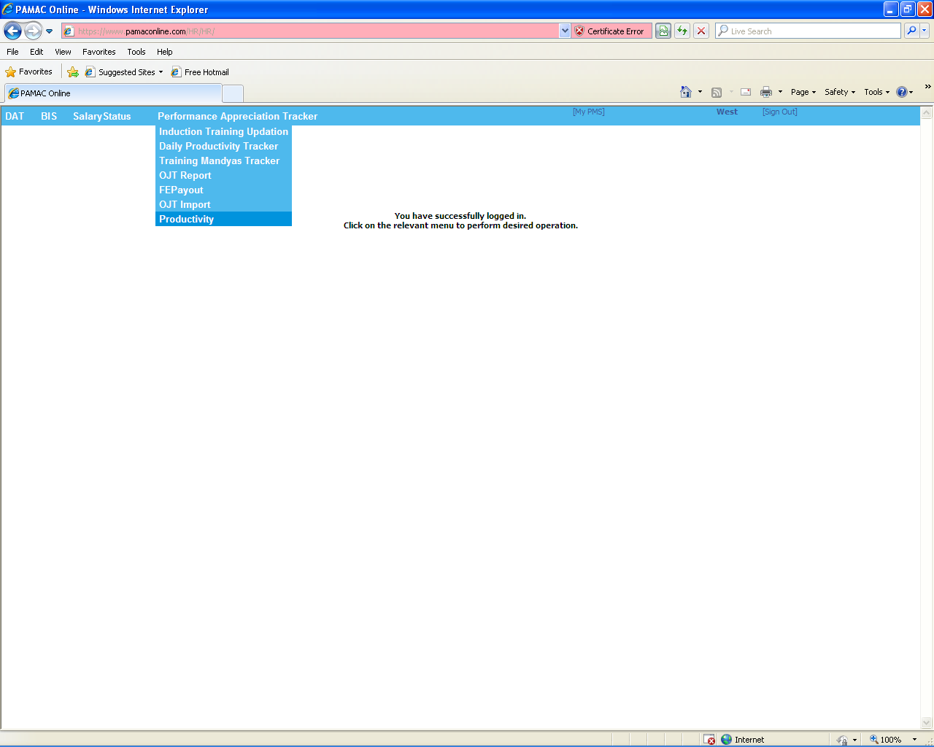
3) Select “Add/Update BackUp”.

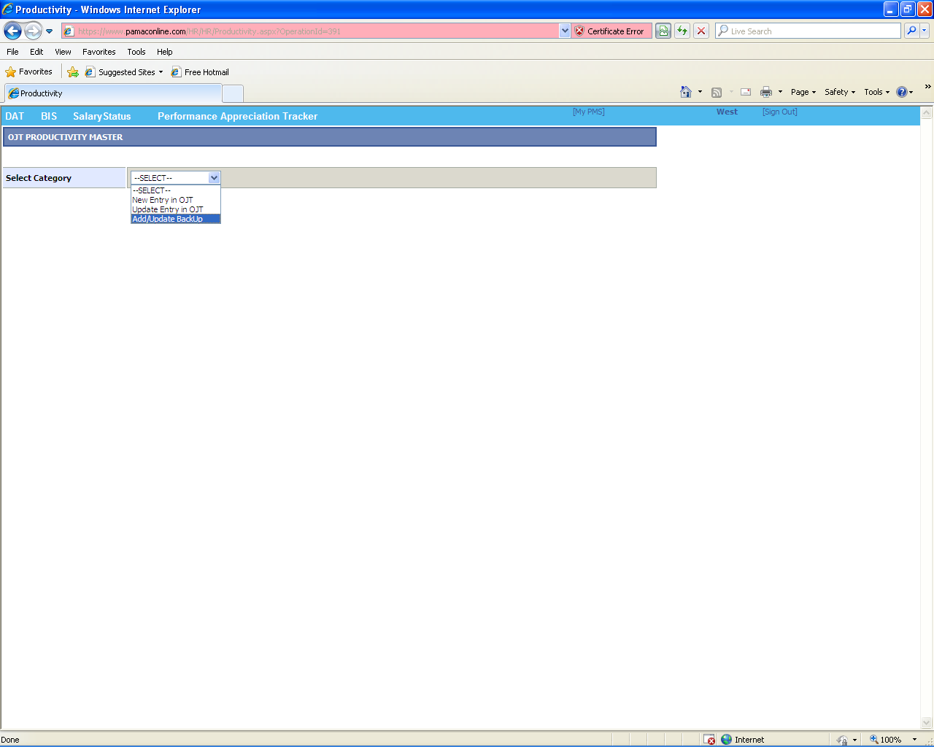
4) Search Employee details to ADD/UPDATE the BACKUP Name against Particular UPDATING AUTHORITY in OJT by
- Selecting “Cluster Name” from which the UPDATING AUTHORITY belongs to.
- Entering “Employee Code” of the Updating Authority.

After fetching the entire Employee details click on “EDIT” link button as shown below to ADD/UPDATE the BACKUP Name in OJT.

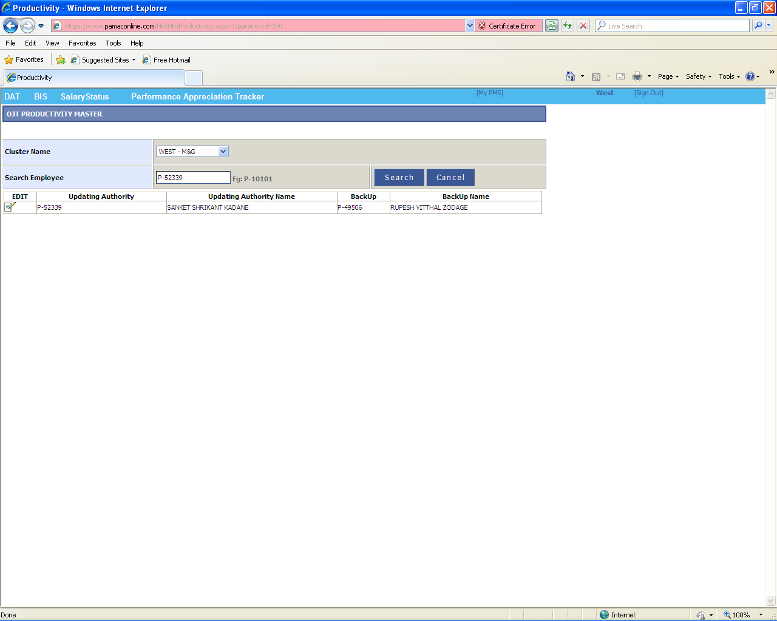
5) Click on “SAVE” button to ADD/UPDATE the BACKUP Name in OJT record for that particular Updating Authority as shown below.

NOTE:

- “Updating Authority Employee Code” must be Employee Code who will update daily Productivity in OJT.
- “BackUp Employee Code” must be Employee Code who will update daily Productivity in absence of Updating Authority in OJT.

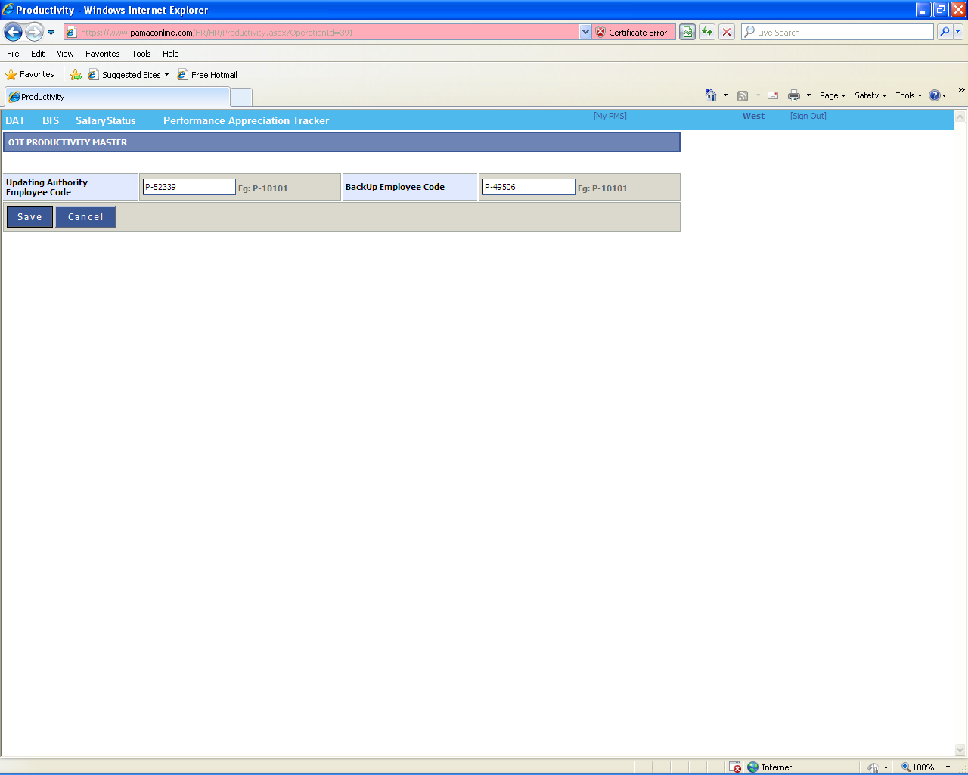
6) Print message will be visible after Adding/Updating BACKUP NAME against Particular UPDATING AUTHORITY in OJT as shown below.

